
DEPARTMENT OF NATURAL SCIENCES
NATURAL SCIENCES
FORMAL ASSESSMENT TASK
PRACTICAL INVESTIGATION
2026

GRADE 8

TOTAL MARKS: 30

Name: ________________________________________________________

Class: __________________________ Date: ________________________

30

ENGLISH FIRST ADDITIONAL LANGUAGE

NOVEMBER 2011

ENGLISH FIRST ADDITIONAL LANGUAGE

NOVEMBER 2011

MARKS OBTAINED =

Background Information:
Electricity is used all around us in our daily lives. Electricity is used to make electric devices work, such as making a light bulb glow or driving machines like cars and toys. All electricity must be in a closed electrical circuit. The circuit has a power source that provides electrical energy, electrical devices that transfer electrical energy into other energy forms and conducting wires that connect the power source and electrical devices. The components in an electric circuit can either be connected in series or parallel. Components that are connected in series will behave differently to the components that are connected in parallel. For example, if a light bulb that is connected in series to other light bulb stops working, all the other light bulbs will stop working. If the light bulb is connected in parallel to the other light bulbs, all the other light bulbs will continue to work. For this reason, the lighting system in our houses is connected in parallel. It is important for us to understand the difference between series and parallel circuits, and the effects of connecting components in this manner.
When cells are connected together they are called a battery. What happens when we put more than one cell in a circuit? You are then expected to setup a circuit and observe what happens when we add cells, in series, to a circuit.

INVESTIGATION: What happens when we add more resistors in series?
AIM:
To investigate the effect of adding resistors to a series circuit.
HYPOTHESIS:
Write a hypothesis for this investigation. (2)
________________________________________________________________________________________________________________________________________________
APPARATUS:
• 1,5 V cells
• 3 torch bulbs
• Insulated copper conducting wires
• Switch
• Ammeter

METHOD:
1. Construct the circuit with the cell, the ammeter, 1 bulb and the switch in series.
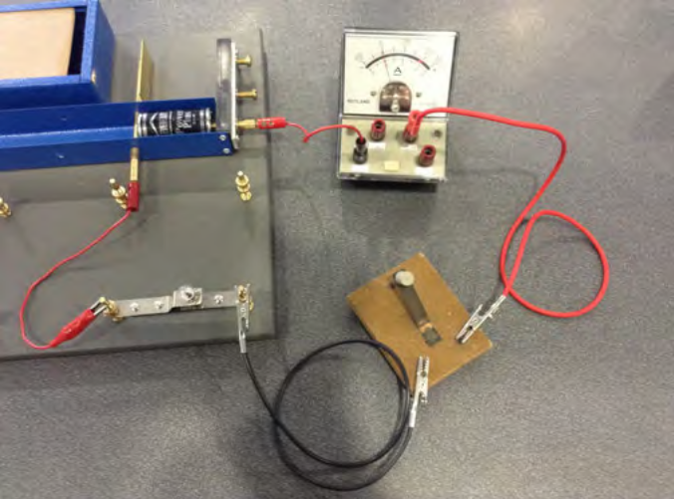
2. Close the switch, or the circuit if you are not using a switch.
3. Note how brightly the bulb is shining and write down the brightness of the bulb.(1)
________________________________________
Draw a circuit diagram. (4)
4. Open the switch.
5. Add another light bulb into the circuit.
6. Close the switch.
7. Note how brightly the bulbs are shining and write down the brightness of the bulb compared to the previous connection.
_______________________________________________________________ (1)

Draw a circuit diagram. (4)

8. Open the switch.
9. Add the third light bulb into the circuit.
10. Close the switch.
11. Note now how brightly the bulbs are shining. (1)
_____________________________________________________________
Draw a circuit diagram for the last circuit you built. (4)

RESULTS:
Complete the table: (3)
NUMBER OF BULBS | BRIGHTNESS
1
2
3

Draw a graph to show the relationship between the number of bulbs and the current. (4)

ANALYSIS:
- What happened to the brightness of the bulbs as the number of bulbs increased? (1)
____________________________________________________________________________________________________________________________________
- When you had two bulbs, did they glow with the same brightness, or was one brighter than the other? (1)
____________________________________________________________________________________________________________________________________
- When you had three bulbs, did they glow the same as each other or was one brighter than the others? (1)
____________________________________________________________________________________________________________________________________
- What do your answers to the previous questions tell you about the current in the series circuit? (1)
____________________________________________________________________________________________________________________________________
CONCLUSION:
- Based on your answers, what conclusions can you draw from this activity? (2)
____________________________________________________________________________________________________________________________________

